**ANALYSING SMARTPHONE FEATURES AND MARKET TRENDS**

**A PROJECT REPORT**

**Submitted by**

**AISHWARIYA (22ADR002)**

**HARSHINI B (22ADL127)**

***For***

**22ADF01 DATA ANALYSIS**

**DEPARTMENT OF ARTIFICIAL INTELLIGENCE**



**KONGU ENGINEERING COLLEGE**

**(Autonomous)**

**PERUNDURAI ERODE – 638 060**

**NOVEMBER 2024**

**DEPARTMENT OF ARTIFICIAL INTELLIGENCE**

**KONGU ENGINEERING COLLEGE**

**(Autonomous)**

**PERUNDURAI ERODE – 638 060**

**NOVEMBER 2024**

**22ADF01 – Data Analysis Project Report**

**Signature of course in-charge Signature of the HOD**

Submitted for the continuous Assessment viva voice examination held on _____________

**EXAMINER I EXAMINER II**

**ABSTRACT**

In recent years, advancements in data analytics have significantly enhanced the ability to interpret consumer behaviour and market trends within the technology sector. This analysis focuses on the smartphone industry, where competitive market dynamics and rapid innovation drive consumer preferences. Utilizing Power BI, this project aims to provide comprehensive insights into the smartphone market, examining factors such as price, brand, operating system, and key specifications. By analyzing a rich dataset of smartphone attributes, including price points, release years, and specifications, the project identifies patterns and trends that influence consumer decisions. Through Power BI various visualizations are created to illustrate insights across multiple dimensions, including comparisons of brand popularity, model features, and market distribution by price. Calculated measures, columns, and DAX expressions are employed to derive meaningful metrics, such as the highest-priced model by operating system and the correlation between device specifications and pricing. These insights are presented in an interactive Power BI dashboard that allows stakeholders to view trends and make informed decisions. The result is a robust analytical tool providing valuable, data-driven insights for stakeholders in the smartphone industry to drive strategic planning and customer engagement.

**TABLE OF CONTENTS**

|  |  |  |
| --- | --- | --- |
| **CHAPTER No.** | **TITLE** | **PAGE NO.** |
|  | **ABSTRACT** | 3 |
|  |  |  |
| 1. | **INTRODUCTION** | **5** |
|  | 1.1 INTRODUCTION | 5 |
|  | 1.2 DATA COLLECTION | 5 |
|  | 1.3 PROBLEM STATEMENT | 6 |
|  | 1.4 BUSINESS OBJECTIVE | 7 |
| **2.** | **DATA PREPARATION** | **8** |
|  | 2.1 DATA CLEANING | 8 |
|  | 2.2 DATA TRANSFORMATION | 8 |
|  | 2.3 DAX FUNCTIONS | 11 |
| **3** | **DATA ANALYSIS AND INTERPRETATION** | **13** |
|  | 3.1 DATA ANALYSIS | 13 |
|  | 3.2 PUBLISHING DASHBOARD | 20 |
|  | 3.3 INFERENCE | 24 |
| **4** | **CONCLUSION** | **27** |
|  | 4.1 RECOMMENDATIONS | 27 |
| **5** | **REFERENCES** | **28** |

**CHAPTER 1**

**INTRODUCTION**

1. **INTRODUCTION**

* This project focuses on the analysis and visualization of smartphone data using Power BI, enabling comprehensive insights into key trends within the smartphone industry.
* The dataset, sourced from Gigasheet, is available in CSV format and includes essential attributes such as model, brand, price, operating system, and key specifications. These fields provide the foundation for in-depth exploration of patterns and relationships that inform consumer preferences, technological advancements, and market dynamics.
* By utilizing Power BI, a powerful and scalable platform for business intelligence, this analysis aims to transform raw data into actionable insights through interactive dashboards. Key calculations and summarizations are performed using DAX expressions, enabling the creation of metrics and measures critical for meaningful visualizations.
* Power BI offers both desktop and cloud-based services, collectively referred to as "Power BI Services," which provide tools for data preparation, visualization, and dashboard creation.
* This analysis not only supports strategic planning for businesses within the technology sector but also offers insights into consumer behavior, pricing trends, and feature popularity among smartphones.\\

1. **DATA COLLECTION**

Data collection is a critical step in the research process, involving the gathering, measurement, and analysis of relevant insights to inform research objectives and validate hypotheses. In this project, the dataset on smartphones, which includes information such as model, brand, operating system, price, and key specifications, was sourced from Gigasheet. This dataset is available in CSV format, which is commonly used for data storage and sharing due to its simplicity and compatibility with most data analysis tools. The data was imported into Power BI for analysis, allowing for efficient pre-processing, visualization, and reporting.

**DATASET**

Source: Gigasheet

Number of rows: 980

Dataset link: <https://www.gigasheet.com/sample-data/real-world-smartphones-dataset>

* **Brand and Model:** The manufacturer and specific model of the smartphone.
* **Price and Rating:** The cost of the smartphone and its average user rating out of 10.
* **5G Support:** Indicates whether the smartphone supports 5G connectivity.
* **Processor:** The type or brand of processor used in the smartphone (e.g., Snapdragon, Exynos).
* **Number of Cores:** The total number of processing cores in the smartphone’s CPU.
* **Fast Charging:** Indicates whether the smartphone has fast-charging capabilities.
* **RAM Capacity:** The amount of RAM memory available in the smartphone, measured in GB.
* **Internal Storage Capacity:** The built-in storage space of the smartphone, measured in GB.
* **Screen Size and Resolution:** The display size in inches and screen resolution (e.g., 1080x2400).
* **Camera:** Details on camera specifications, including megapixels or features like dual camera setup.
* **Operating System (OS**): The smartphone's operating system, typically Android or iOS.

1. **PROBLEM STATEMENT**

Analyzing smartphone data presents significant challenges due to the vast amount of information available regarding different models, specifications, and user preferences. For consumers and stakeholders in the smartphone market, it is crucial to visualize this data clearly and intuitively. Many potential customers may lack technical expertise, making it essential to present data in a user-friendly manner that facilitates easy analysis of smartphones. The primary challenge is to create visualizations that not only summarize the performance of smartphones but also allow for comparisons between various models based on attributes like price, features, and ratings. Thus, the analysis seeks to provide comprehensive insights into smartphone performance, user satisfaction, and market trends.

1. **BUSINESS OBJECTIVE**

* To compare and analyze the summary of each smartphone model and visualize them using Power BI.
* To assess the performance of smartphone brands across the 2022 season, identifying trends and consumer preferences.
* To facilitate comparisons among various smartphone models and brands based on key features and user ratings.
* To evaluate the performance of individual smartphone components (such as cameras and processors) and reward innovations that enhance user experience.
* To identify standout models in terms of user satisfaction and performance, potentially recognizing the “Best in Class” for various categories.

**CHAPTER 2**

**DATA PREPARATION AND MODELING**

1. **DATA CLEANING**

Data cleaning is a critical step in data preprocessing, aimed at ensuring the accuracy and reliability of the dataset. This process involves identifying and rectifying errors, filling in missing values, removing outliers, and smoothing noisy data. Missing values are handled by one of the following methods listed below. In this analysis, various strategies were employed to address missing values:

* Rows with multiple missing attributes were excluded from the dataset to maintain data integrity.
* For individual missing values, data was manually filled using reliable sources.
* Missing values were also filled using the mean of the attribute, ensuring a minimal impact on overall data distribution.
* In some instances, the most frequent value was used to fill in the gaps.

These methods were applied to create a completer and more accurate dataset for analysis.

1. **DATA TRANSFORMATION**

Data transformation is the process of converting data from one format or structure to another, which is essential for effective data management and integration. This phase is crucial in preparing the data for analysis, especially when dealing with diverse sources. The transformation process includes:

* Application Integration: Ensuring that data from various applications can work together seamlessly.
* Data Wrangling and Warehousing: Refining data for analysis and storing it appropriately.
* Manual and Automated Procedures: Depending on the complexity and volume of data, both manual input and automated processes are utilized.

In this project, a significant transformation involved creating a price_range column to categorize smartphone prices into specified ranges using the conditional column option. This simplification aids in comparative analysis across different price segments.

**STEP 1**

1. Go to HOME tab in ribbon.
2. Click on GET DATA and select data from the system or from any platform where it resides.
3. Here, select a dataset from a system and load it to POWER BI.

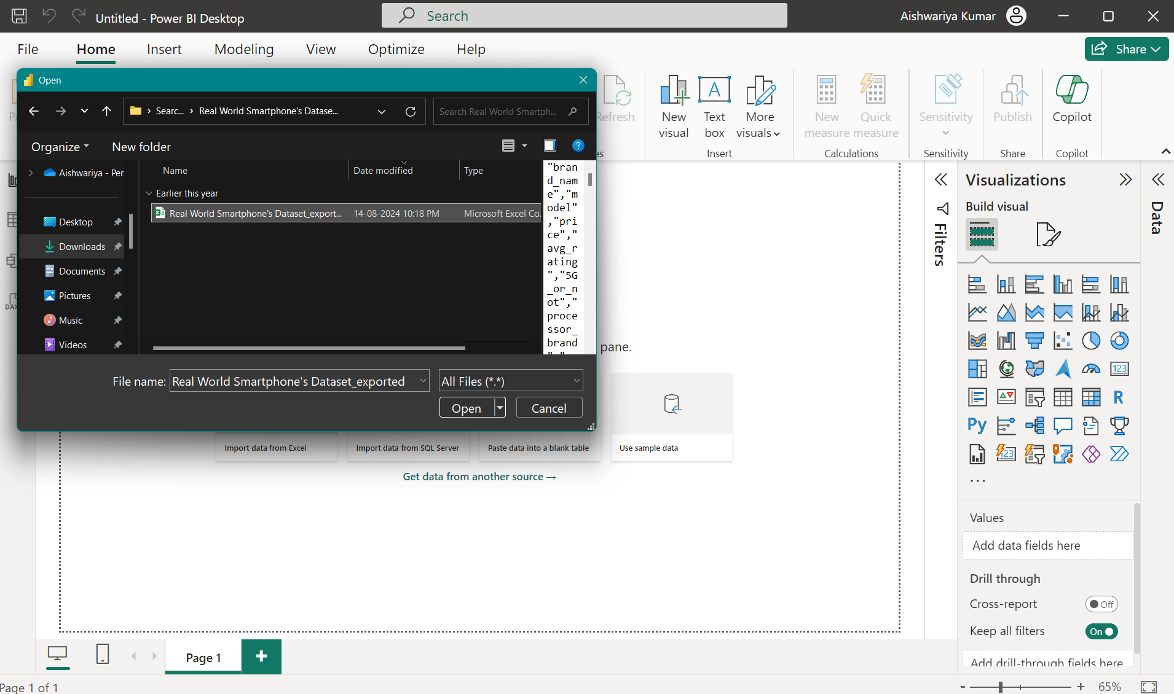

Figure 2.2.1 Select Dataset

**STEP 2**

1. Select TRANSFORM DATA option to transform data.

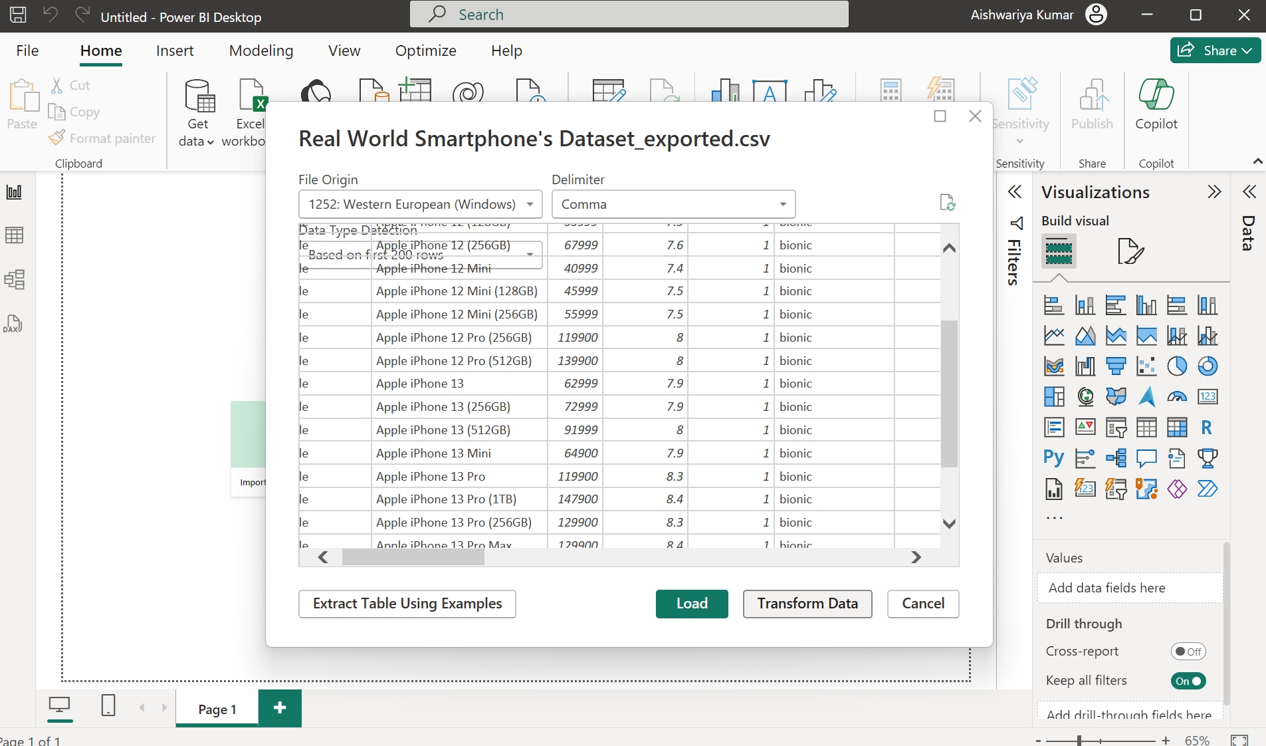

Figure 2.2.2 Transform Dataset

**STEP 3**

1. Now select table to be transformed.
2. Go to ADD COLUMN tab and click CONDITIONAL COLUMN option.
3. Add the necessary conditions to create a new “price_range” column

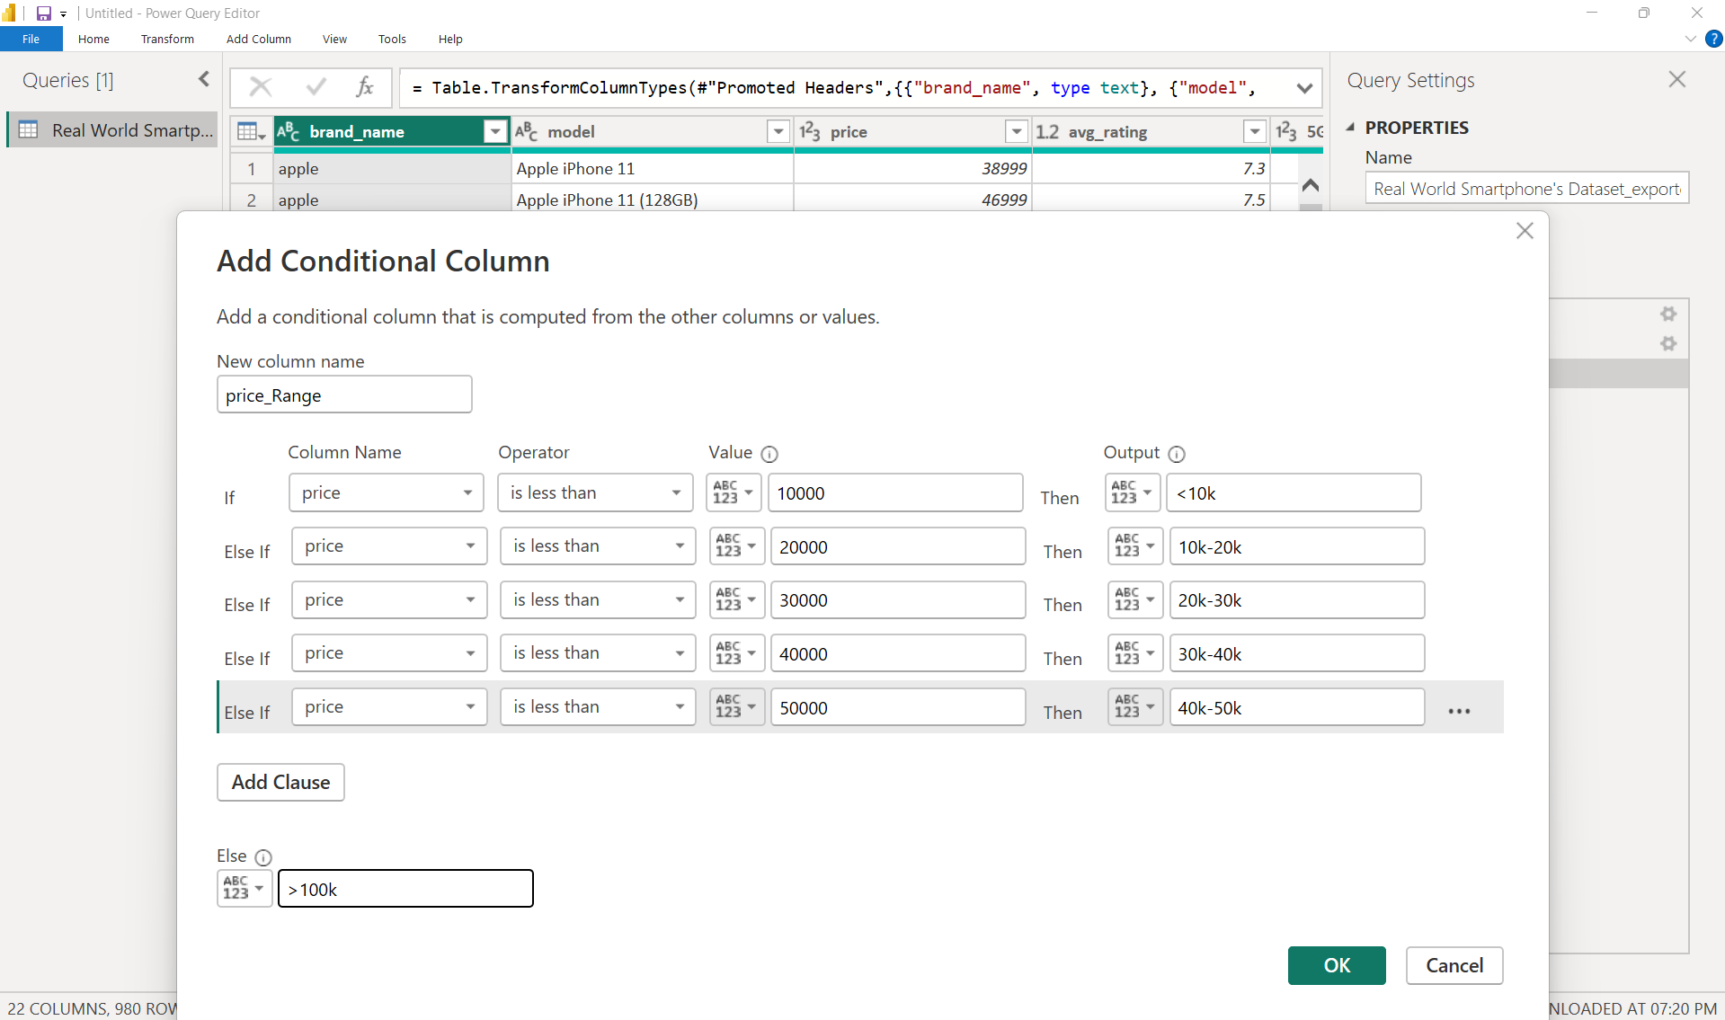

Figure 2.2.3 Create Conditional Column

**STEP 4**

1. Click APPLY AND CLOSE option in HOME tab to save changes.

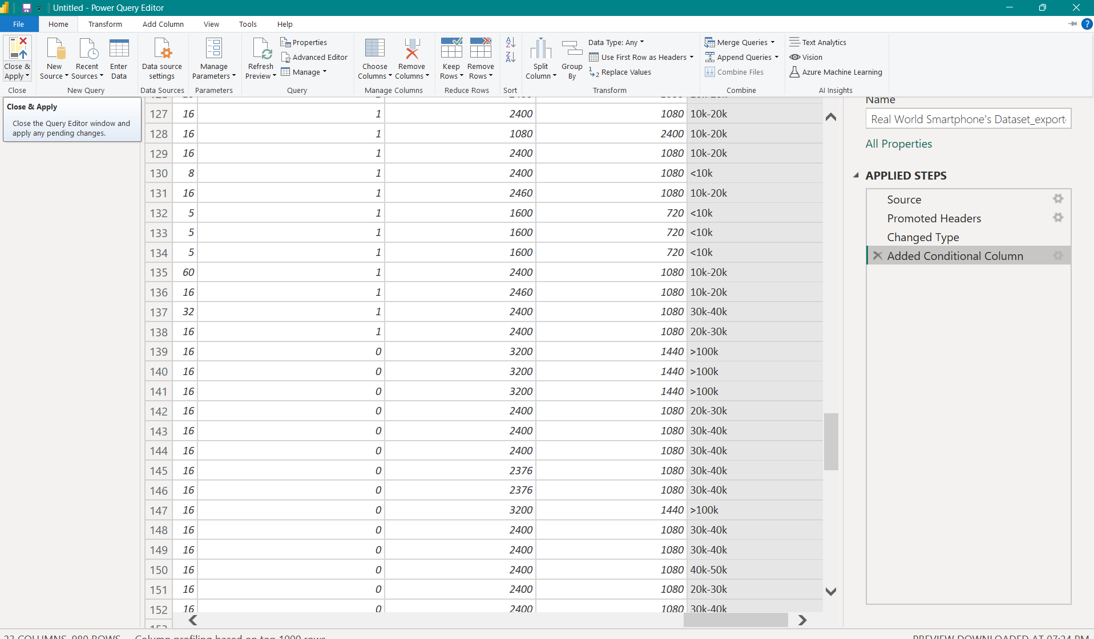

Figure 2.2.4 Save changes

1. **DAX FUNCTIONS**

DAX is a powerful formula language used in Power BI to perform calculations and data analysis. It consists of a collection of operators, functions, and expressions that enable the creation of new insights from existing data. DAX facilitates the development of:

* Calculated Columns: Adding new columns based on existing data.
* New Measures: Creating dynamic calculations that can change based on user interactions.
* Customized Tables: Formulating tables tailored to specific analytical needs.
* Quick Measures: Simplified calculations to expedite analysis.
* Time Intelligence: Functions that operate on time-based data, allowing for effective period comparisons and calculations.

DAX formulas allow for various statistical operations, such as finding maximum, minimum, average, count, sum, and percentage calculations, among others. In this project we used DAX measures for analysis.

**STEP 1**

1. Click NEW MEASURE option in TABLE TOOLS tab

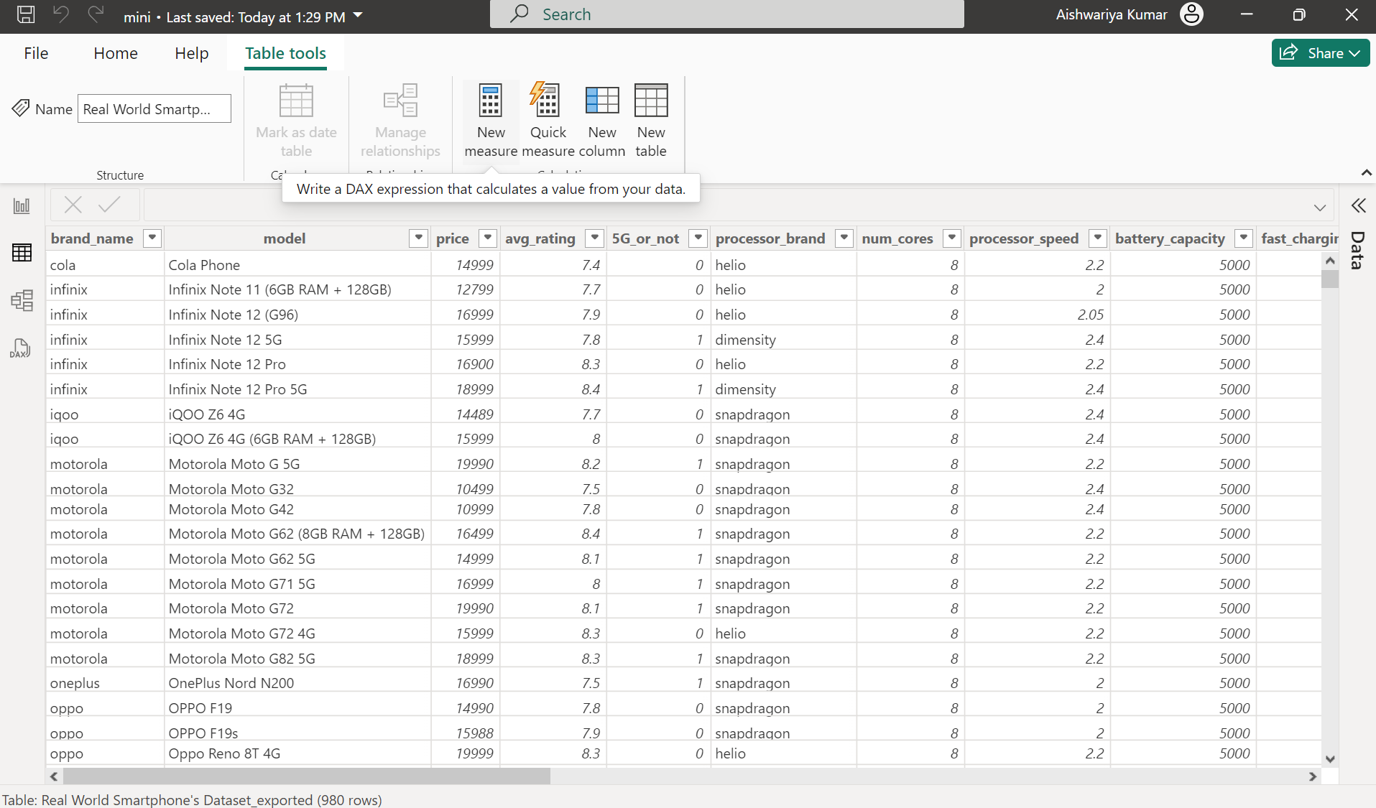

Figure 2.3.1 Click New Measure

**STEP 2**

1. Enter the DAX query to create measure and press Enter. The required measure is created successfully.

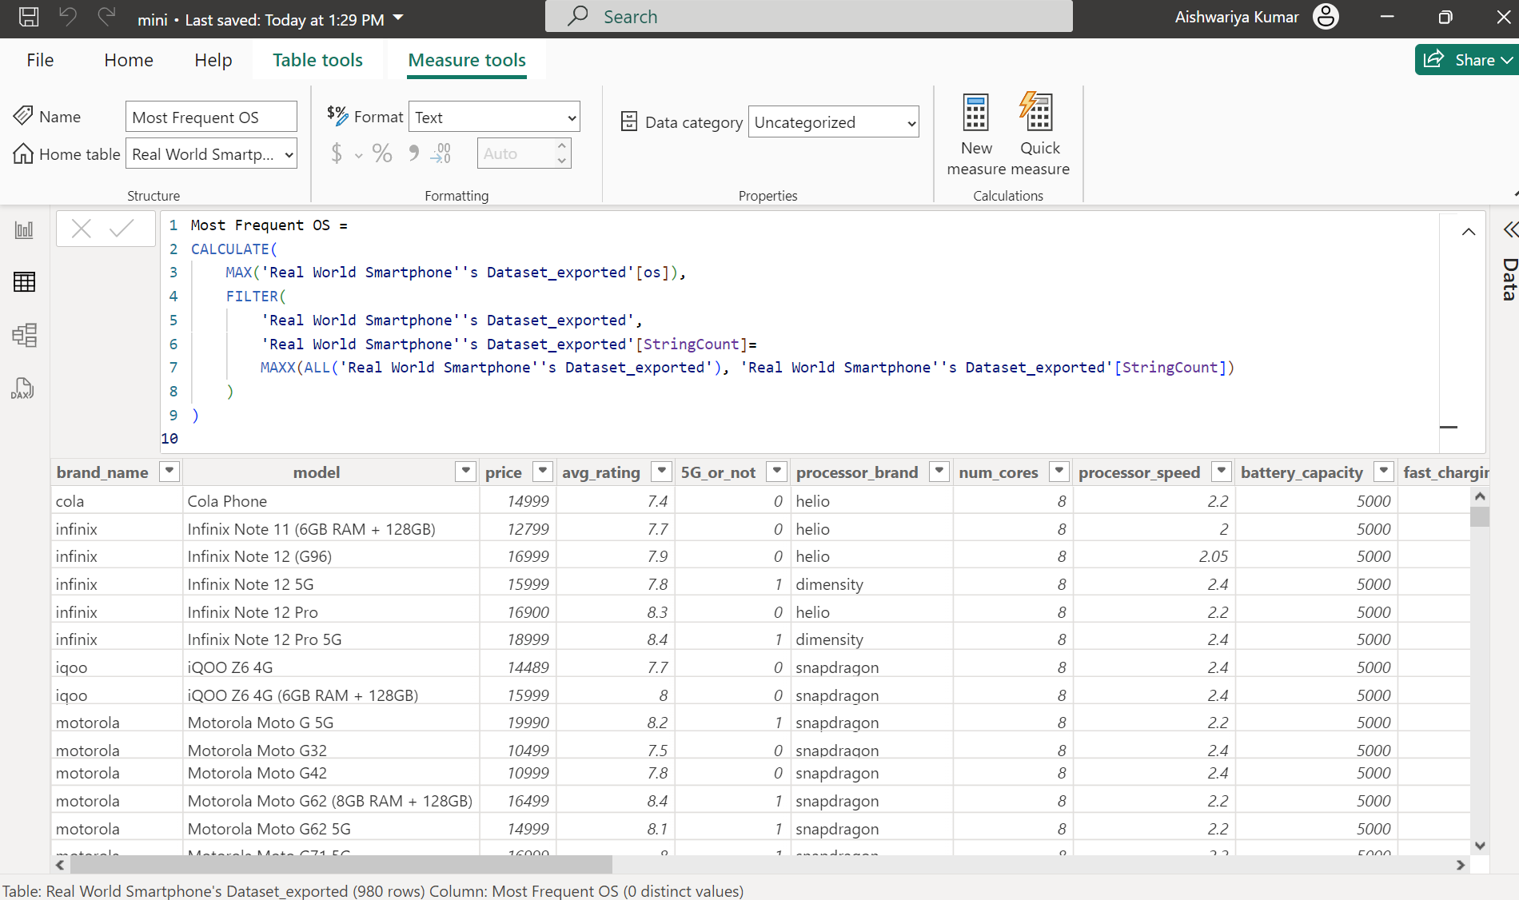

Figure 2.3.2 Create New Measure

The measures created in this project are:

* Costliest phone
* Constliest iphone
* 5G phone count
* Most frequent OS
* Max_cost
* Max_ios_price

**CHAPTER 3**

**DATA ANALYSIS AND INTERPRETATION**

1. **DATA ANALYSIS**
2. **Does price affect rating of phone?**
3. Chose area chart for visualization
4. Choose price_range column for x-axis
5. Choose avg_rating column for y-axis

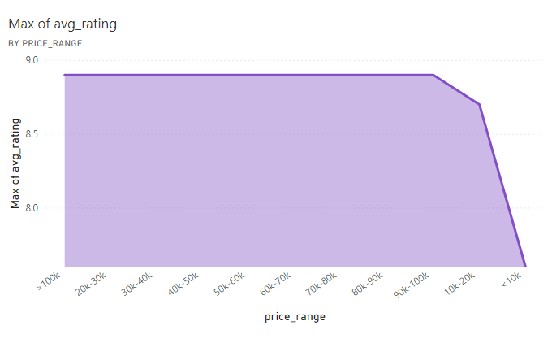

Figure 3.1.1 Price vs Rating

1. **Does 5G and fast charging affect the price?**
2. Chose clustered column chart for visualization
3. Choose 5G_or_not column for x-axis
4. Choose fast_charging_available column for y-axis

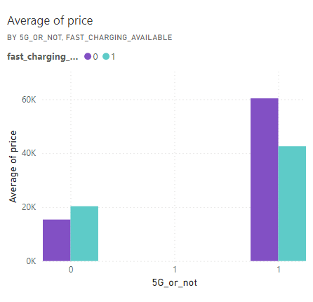

Figure 3.1.2 5G and Fast charging vs Price

1. **Which processor have highest rating?**
2. Chose pie chart for visualization
3. Choose processor_brand column for lengend
4. Choose avg_rating column for values

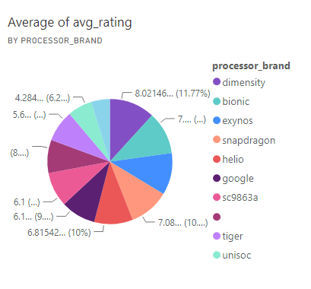

Figure 3.1.3 Processor with highest average Rating

1. **Which OS have highest rating?**
2. Chose donut chart for visualization
3. Choose os column for legend
4. Choose avg_rating for values

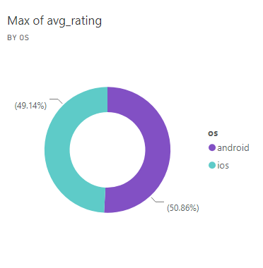

Figure 3.1.4 OS with highest average high

1. **Identify the best rated model in each brand.**
2. Choose column chart for visualization
3. Choose model column for x-axis
4. Choose avg_rating column for y-axis
5. Create a slicer for brand_name

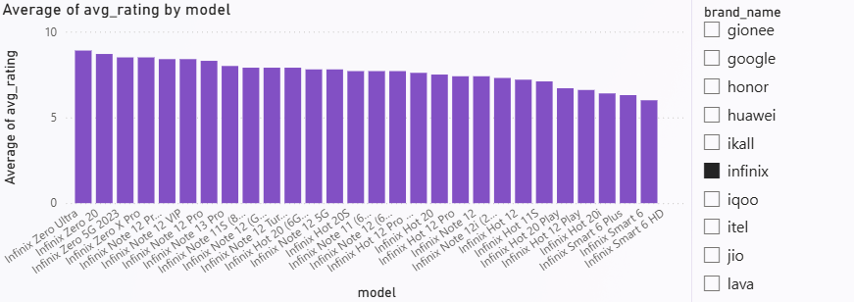

Figure 3.1.5 rating

1. **Which brand provides best front and rear camera?**
2. Chose clustered column chart for visualization
3. Choose brand_name column for x-axis
4. Choose primary_camera_front and primary_camera_rear columns for y-axis

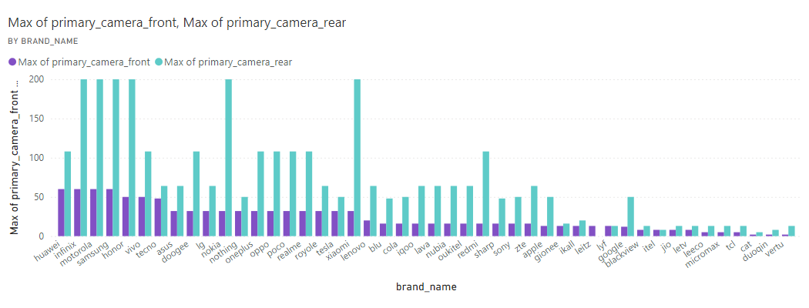

Figure 3.1.6 Brand that provides high camera quality

1. **Models with high processor speed and battery capacity.**
2. Chose line chart for visualization
3. Choose brand_namecolumn for x-axis
4. Choose processor_speed column for primary y-axis
5. Choose battery_capacit column for secondary y-axis

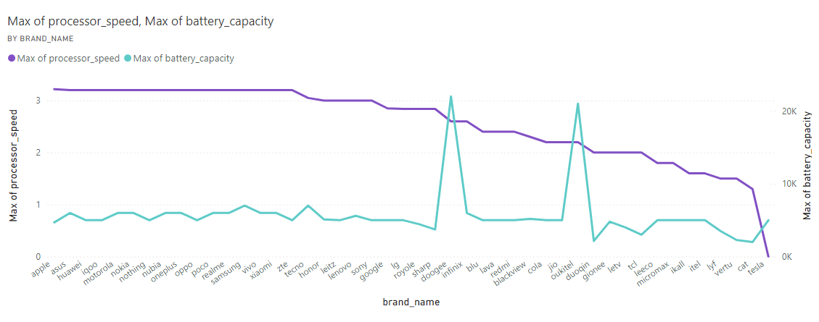

Figure 3.1.7 Processor speed and Battery capacity

1. **Identify the best rated brand in each price range.**
2. Chose column chart for visualization
3. Choose brand_name column for x-axis
4. Choose avg_rating column for y-axis
5. Create a slicer for price_range

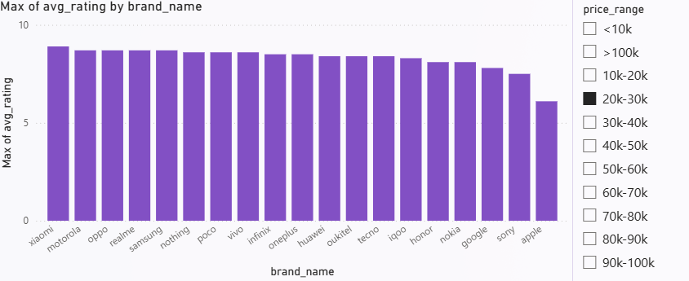

Figure 3.1.8 Best brand in each price range

1. **Which brand with high internal memory?**
2. Chose donut chart for visualization
3. Choose brand_name column for legend
4. Choose internal_memory column for values

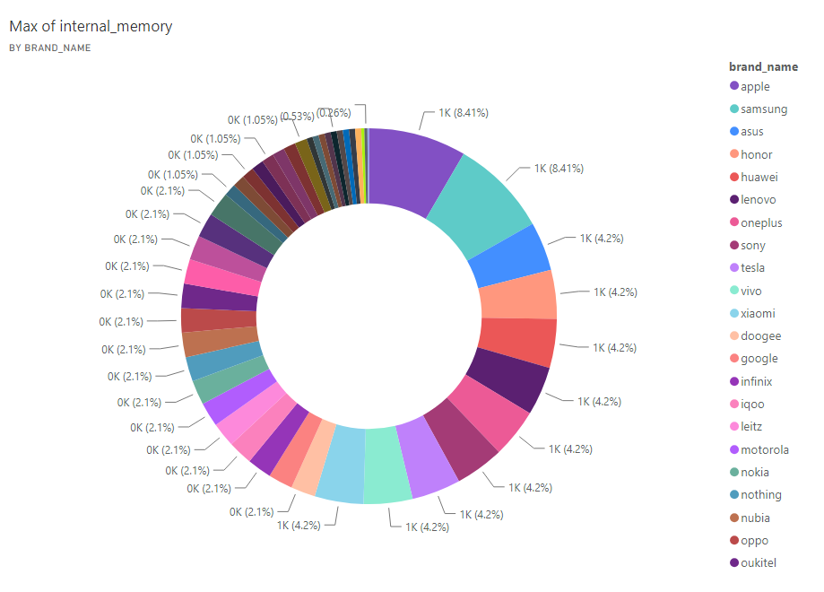

Figure 3.9.1 Brand with high internal memory

1. **Does camera quality affect rating?**
2. Chose line chart for visualization
3. Choose primary_camera_front column for x-axis
4. Choose avg_rating column for y-axis

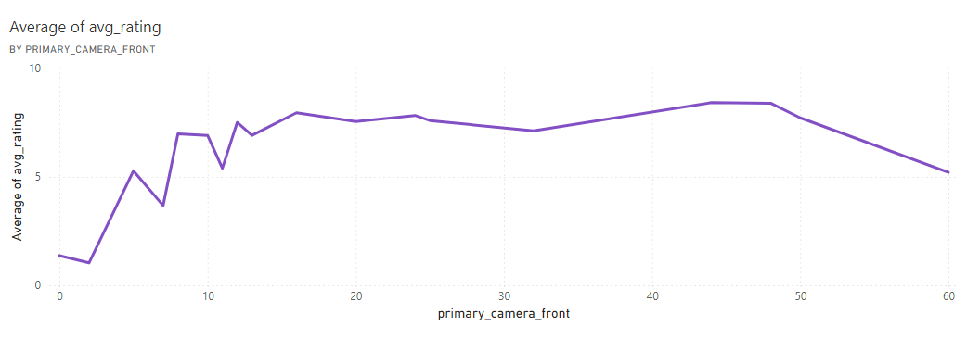

Figure 3.1.10 Camera quality vs Rating

1. **What is the costliest phone?**

costliest_phone =

CALCULATE(

    FIRSTNONBLANK('Real World Smartphone''s Dataset_exported'[model], 1),

    FILTER(

        'Real World Smartphone''s Dataset_exported',

        'Real World Smartphone''s Dataset_exported'[price] = MAX('Real World Smartphone''s Dataset_exported'[price])

    ))

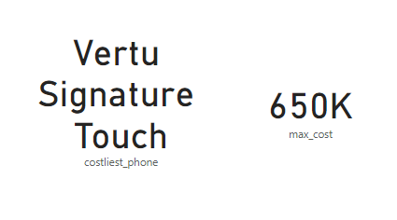

Figure 3.1.11 Costliest phone

1. **What is the average price of smartphones by brand?**
2. Chose treemap chart for visualization
3. Choose brand_name column for category
4. Choose price column for values

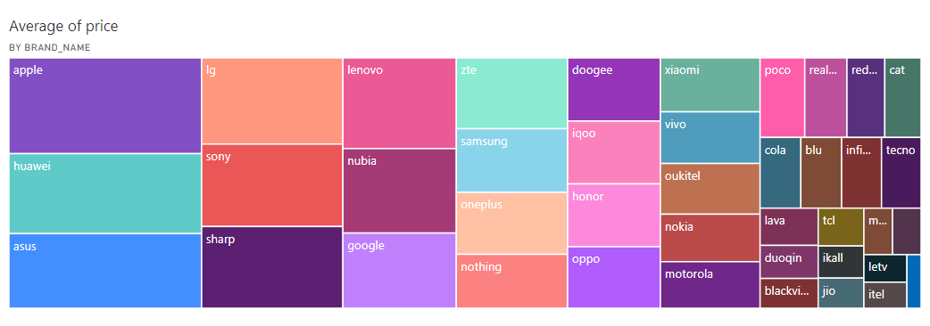

Figure 3.1.12 Average price by Brand

1. **How many smartphones supports 5G connectivity?**

5G phones count = CALCULATE(COUNT([5G_or_not]),FILTER('Real World Smartphone''s Dataset_exported',[5G_or_not]=1))

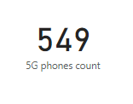

Figure 3.1.12 Count of 5G smartphones

1. **What is the costliest iPhone?**

costliest_iphone =

LOOKUPVALUE(

    'Real World Smartphone''s Dataset_exported'[model],

    'Real World Smartphone''s Dataset_exported'[price], [max_ios_price],

    'Real World Smartphone''s Dataset_exported'[os], "iOS")

max_ios_price =

CALCULATE(

    MAX('Real World Smartphone''s Dataset_exported'[price]),

    'Real World Smartphone''s Dataset_exported'[os] = "iOS")

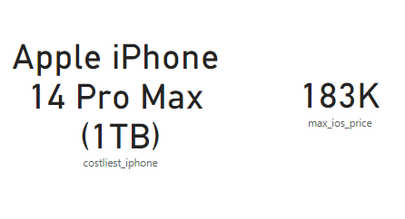

Figure 3.1.14 costliest iPhone

1. **What is the most common OS across all smartphones.**

StringCount =

CALCULATE(

    COUNTROWS('Real World Smartphone''s Dataset_exported'),

    ALLEXCEPT('Real World Smartphone''s Dataset_exported', 'Real World Smartphone''s Dataset_exported'[os]))

Most Frequent OS =

CALCULATE(

    MAX('Real World Smartphone''s Dataset_exported'[os]),

    FILTER(

        'Real World Smartphone''s Dataset_exported',

        'Real World Smartphone''s Dataset_exported'[StringCount]=

        MAXX(ALL('Real World Smartphone''s Dataset_exported'), 'Real World Smartphone''s Dataset_exported'[StringCount]))

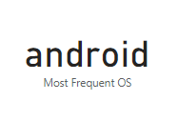

Figure 3.1.15 Commonly used OS

1. **PUBLISHING DASHBOARD**

* Once a Power BI dashboard is designed, it can be published to the Power BI service, making it accessible for users to view and interact with via a web browser or mobile app. This enables teams to access insights in real-time without the need for desktop software.
* Publishing to the Power BI service allows for sharing and collaboration. Dashboards can be shared with specific users or groups within the organization, ensuring that only authorized users can access sensitive information.
* Power BI provides options for scheduling data refreshes, so published dashboards always display the most recent data. This ensures that decision-makers have up-to-date insights, especially when data changes frequently.
* The Power BI service supports mobile-optimized views, ensuring that published dashboards are accessible and functional on mobile devices, allowing users to interact with data on the go.
* Administrators can monitor usage metrics for published dashboards to gain insights into how often they are accessed and by whom, helping to track dashboard engagement and effectiveness.

**Link for dashboard:** <https://app.powerbi.com/groups/me/reports/b752e754-a32c-443c-9e6f-33b83418ba12/e5d0fe709381c9ab4e60?experience=power-bi>

**Process of creating Dash board**

**STEP 1:** After signing in, click the Publish button on the Home tab. Select My workspace as the destination.

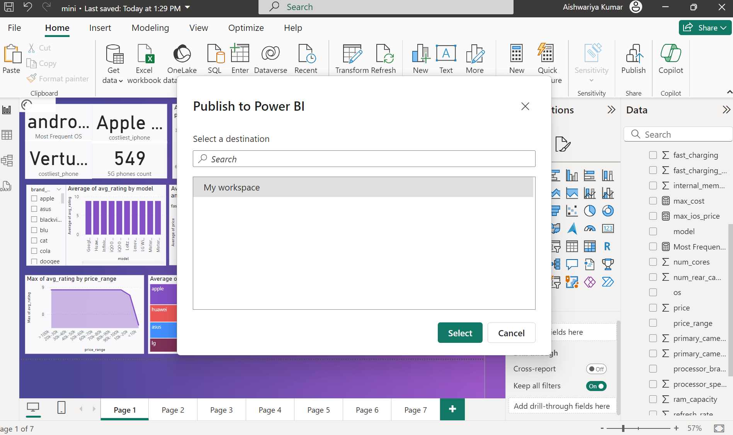

Figure 3.2.1 Publish to power BI

**STEP 2 :** Once published, click the link to open the report in Power BI

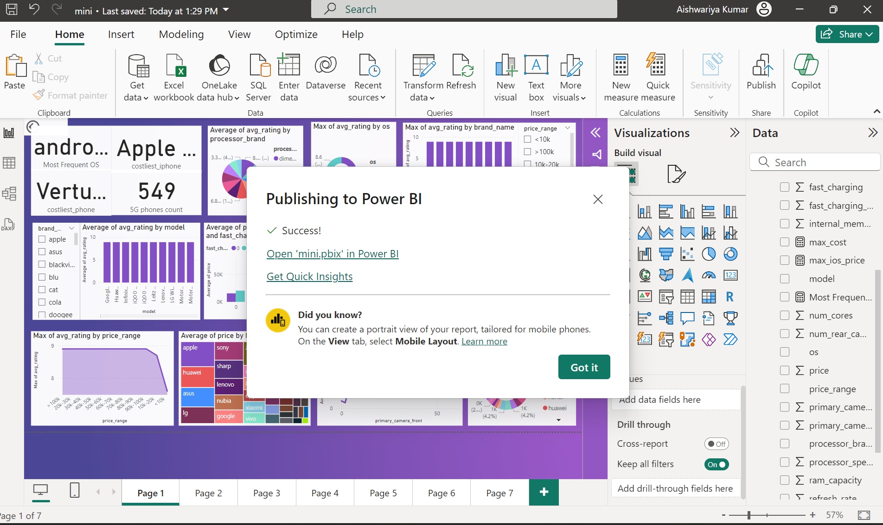

Figure 3.2.2 Publishing to power BI

**STEP 3 :** In the Report view, You should see a pin icon in the upper right corner

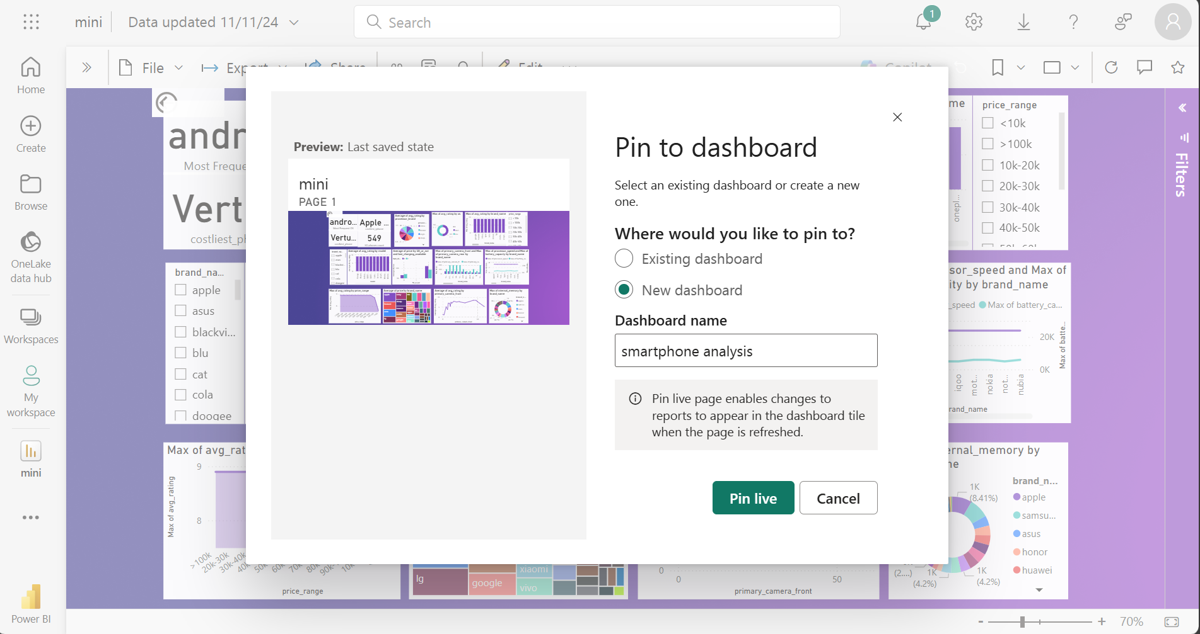

Figure 3.2.3 Pin to dashboard

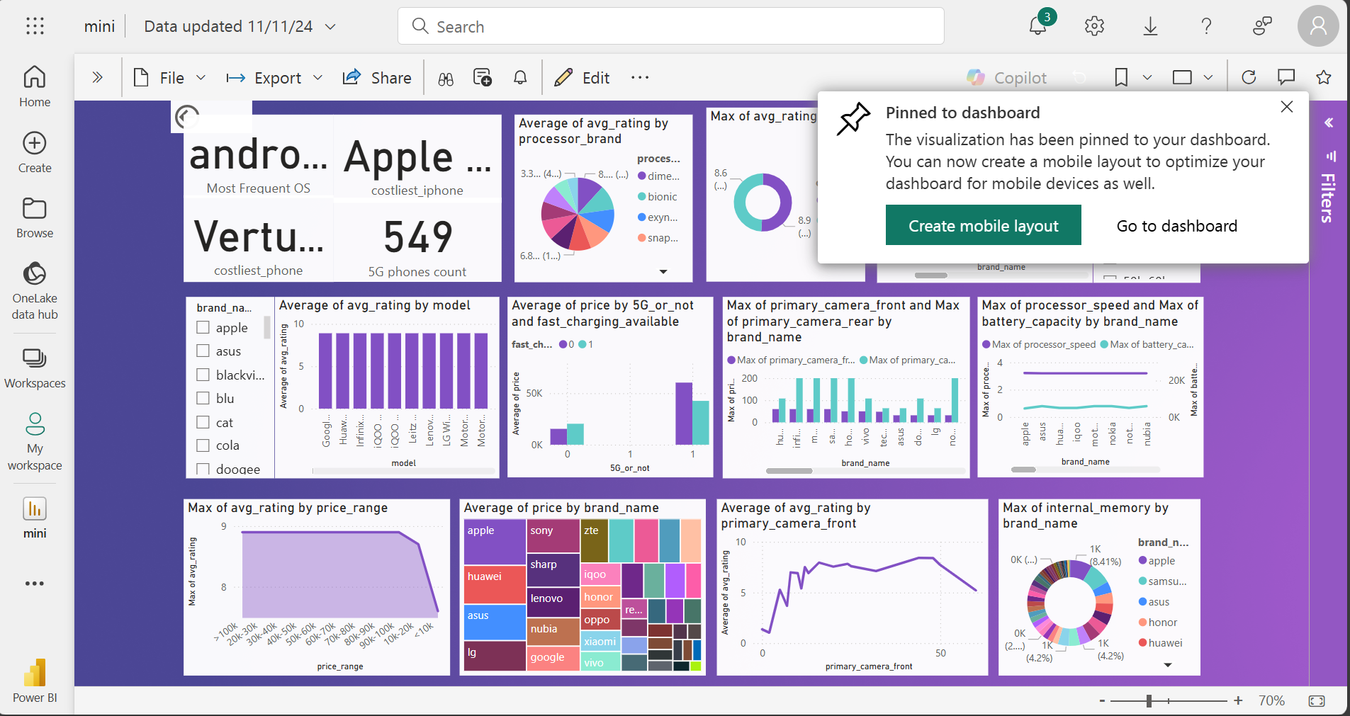

Figure 3.2.4 Pinned to dashboard

**DASHBOARD VIEW:**

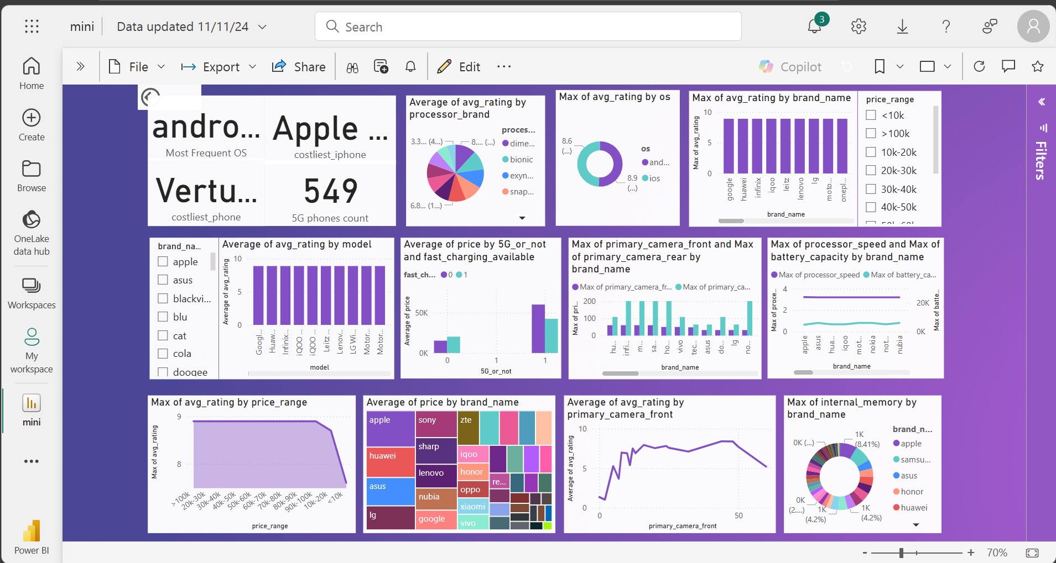

Figure 3.2.5 Created Dashboard

1. **INFERENCES**
2. **Does price affect rating of phone?**

No, price does not affect rating of smartphones. Maximum rating for all for smartphone of almost all price range is 8.90. This suggests that factors such as brand reputation, user satisfaction, and performance metrics might be more important in driving ratings than price alone.

1. **Does 5G and fast charging affect the price?**

Yes, the inclusion of 5G and fast charging is associated with higher prices, highlighting these as premium features that many consumers are willing to pay extra for.

1. **Which processor have highest rating?**

The Dimensity processor, which holds the highest rating of 8.02, reflects a strong user preference for performance efficiency and power, reinforcing the importance of chipset quality in overall smartphone experience.

1. **Which OS have highest rating?**

The highest-rated smartphones run on the Android operating system, showing its strong market presence and user preference across brands and price ranges. Android phones have the highest rating 8.9

1. **Best rated model in each brand.**

Oneplus: onplus 10 pro has the highest rating 8.90

Apple: iphone 13 promax has the highest rating 8.86

Vivo: vivo x80 has the highest rating 8.80

1. **Brand that provides best front and rear camera.**

Infinix, Motorola and Samsung provide best from and rear camera

1. **Models with high processor speed and battery capacity.**

Apple has the highest processor capacity.

Dogee has the highest battery capacity.

1. **Best rated brand in each price range.**

Xioami has the highest rating of 7.60 in price range <10k

Infinix has highest rating of 8.9 in price range 20k-30k

Samsung has highest rating of 8.9 in the the price range 90k-100k

1. **Brand with high internal memory.**

Apple smartphones have high internal memory.

1. **Does camera quality affect rating?**

Yes, camera quality does play a role in smartphone ratings, though ratings are also significantly impacted by factors like battery life, processing speed, and display quality, indicating that users value a balanced combination of features.

1. **What is the costliest phone?**

Vertu signature touch is the costlier phone. The price of this phone is 650k.

1. **What is the average price of smartphones by brand?**

Apple has the highest average price of 95k

Samsung has average price of 36k

Infinix has average price of 14k

1. **How many smartphones supports 5G connectivity?**

549 smartphones out of 980 smartphones have 5G. With over half of the analyzed smartphones supporting 5G, it’s evident that 5G is becoming a standard feature in modern devices, likely shaping future consumer expectations around connectivity.

1. **What is the costliest iPhone?**

Apple iphone 14 Pro Max is the costliest iphone

1. **What is the most common OS across all smartphones.**

Android is the most commonly used OS across smart phones. This shows Android OS strong market presence and user preference across brands and price ranges.

**CHAPTER 4**

**CONCLUSION AND FUTURE WORK**

1. **RECOMMENDATIONS**

The analysis of smartphones reveals a wealth of information that can be overwhelming for consumers trying to make informed purchasing decisions. It is essential to present the necessary details clearly and concisely through visualizations, making the data accessible to a wider audience, including those who may not be tech-savvy.

As the smartphone market continues to evolve, consumers increasingly seek comprehensive insights into features, performance ratings, and price comparisons. Utilizing Power BI enables the creation of interactive dashboards that allow users to track key performance indicators (KPIs) related to smartphone attributes, such as camera quality, battery life, and processor performance, against predefined benchmarks. This functionality not only aids in personal decision-making but also assists retailers and manufacturers in understanding market trends and consumer preferences.

In today's fast-paced environment, potential buyers often lack the time to sift through extensive data. Therefore, summarizing critical information about smartphones—such as best-rated models across various brands, price ranges, and performance metrics—into visually appealing and easy-to-understand dashboards is crucial. This approach can help consumers quickly grasp the essential information they need to make confident purchasing decisions.

In conclusion, preparing an intuitive and interactive dashboard using Power BI will empower users to explore smartphone data effectively, fostering informed choices in an increasingly competitive market. By leveraging the robust business intelligence capabilities of Power BI, stakeholders can centralize critical metrics, facilitate collaboration, and enhance overall consumer engagement.

**REFERENCES**

1. “A Study on Mobile Marketing and its impact on Consumer Buying Behaviour”, JETIR, 2023
2. “Marketing Strategy of Smartphone Companies”, IJCRT, 2021
3. “How smartphone advertising influences consumers purchase intention”, ELSEIVER, 2019
4. “Product and brand-user stereotypes among social classes: Implications for advertising strategy’, Journal of Advertising Research
5. “Impact of Integrated Marketing Communication on Consumer Behaviour: Effects on Consumer Decision Making Process‟, International Journal of Marketing Studies.
6. “Determinants of customer loyalty and financial performance”, Journal of Management Accounting Research
7. “Measuring attitude towards the brand and purchase intentions”, Journal of Current Issues and Research in Advertising
8. “An empirical model for brand loyalty measurement”, Journal of Targeting, Measurement and Analysis for Marketing
9. “Consumer adoption of the internet as an information search and product purchase channel: some research hypotheses”, International Journal of Internet Marketing and Advertising
10. “Influence of discount price announcements on consumer’s behaviour”, Journal of Business Administration